5.33: Without the dolly: 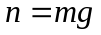and 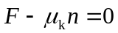 (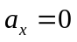 since speed is constant).
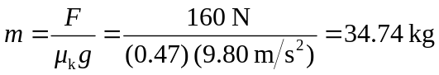
With the dolly: the total mass is 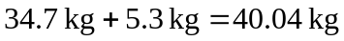 and friction now is rolling friction,